**Step 1** – Click Out’n About! tab

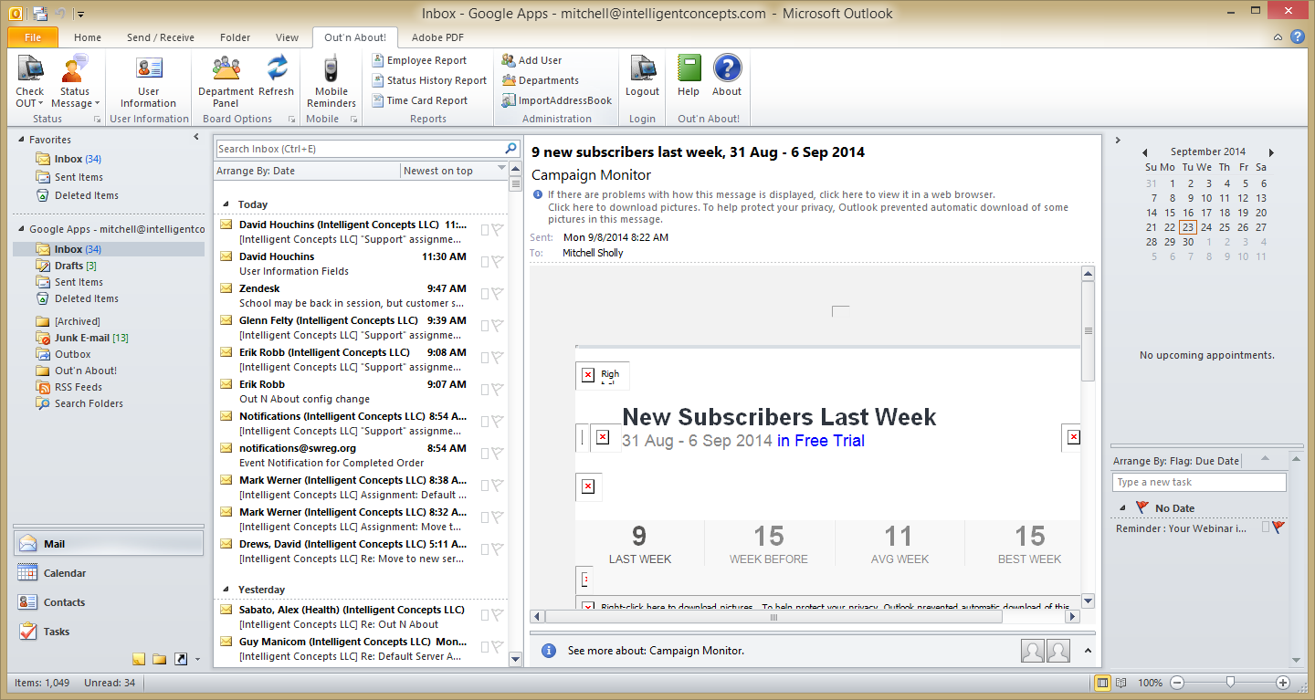

**Step 2** – Click more options button under Board Options.

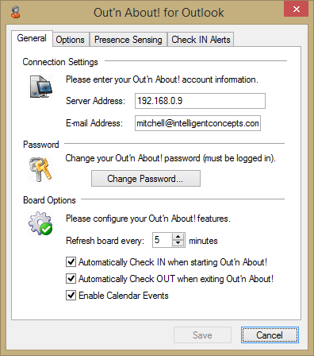

**Step 2** – Paste the {this IP Address}, and you’ll be connected to the new environment

**Step 3** – Click Save